Lab # 6

Process Scheduling (i) First Come First Serve (FCFS) & (ii) Shortest Job First (SJF)

Write shell scripting code for FCFS scheduling and also calculate average waiting time.

First Come First Serve Scheduling Algorithm (FCFS) :
using System;

class Program
{
static void Main(string[] args)
{
int n;
int[] burst_time = new int[20];
int[] waiting_time = new int[20];
int[] turnaround_time = new int[20];
float total_waiting_time = 0;
float total_turnaround_time = 0;

Console.Write("Enter total number of processes (maximum 20): ");
n = Convert.ToInt32(Console.ReadLine());

Console.WriteLine("\nEnter Process Burst Time");
for (int i = 0; i < n; i++)
{
Console.Write("P[" + (i + 1) + "]: ");
burst_time[i] = Convert.ToInt32(Console.ReadLine());
}

waiting_time[0] = 0; // Waiting time for first process is 0

// Calculating waiting time
for (int i = 1; i < n; i++)
{
waiting_time[i] = 0;
for (int j = 0; j < i; j++)
{
waiting_time[i] += burst_time[j];
}
}

// Calculating turnaround time and total turnaround time
for (int i = 0; i < n; i++)
{
turnaround_time[i] = burst_time[i] + waiting_time[i];
total_turnaround_time += turnaround_time[i];
}

// Calculating total waiting time
for (int i = 0; i < n; i++)
{
total_waiting_time += waiting_time[i];
}

// Calculating average times
float avg_turnaround_time = total_turnaround_time / n;
float avg_waiting_time = total_waiting_time / n;

Console.WriteLine("\nAverage Turnaround Time: " + avg_turnaround_time + "ms");
Console.WriteLine("Average Waiting Time: " + avg_waiting_time + "ms\n");

Console.WriteLine("Process\tBurst Time\tWaiting Time\tTurnaround Time");
for (int i = 0; i < n; i++)
{
Console.WriteLine("P[" + (i + 1) + "]\t" + burst_time[i] + "\t\t" + waiting_time[i] + "\t\t" + turnaround_time[i]);
}
}
}

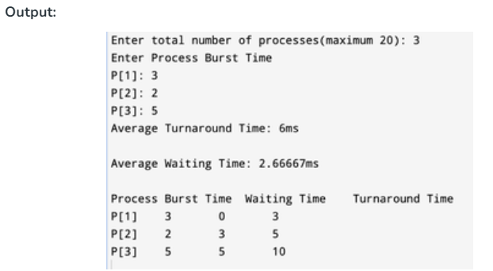

B. Shortest Job First Scheduling Algorithm (SJF)
using System;
using System.Collections.Generic;

public class Process
{
public int Id { get; set; }
public int ArrivalTime { get; set; }
public int BurstTime { get; set; }
public int OriginalBurstTime { get; set; }
public int WaitingTime { get; set; }
public int TurnaroundTime { get; set; }

public Process(int id, int arrivalTime, int burstTime)
{
Id = id;
ArrivalTime = arrivalTime;
BurstTime = burstTime;
OriginalBurstTime = burstTime;
WaitingTime = 0;
TurnaroundTime = 0;
}
}

public class ShortestJobFirst
{
public List<Process> Processes { get; set; }

public ShortestJobFirst(List<Process> processes)
{
Processes = processes;
}

public void Schedule()
{
// Sort processes based on arrival time, then burst time
Processes.Sort((a, b) => {
int compareArrival = a.ArrivalTime.CompareTo(b.ArrivalTime);
if (compareArrival == 0)
{
return a.BurstTime.CompareTo(b.BurstTime);
}
return compareArrival;
});

int currentTime = 0;
int completedProcesses = 0;
int n = Processes.Count;

while (completedProcesses < n)
{
// Find the next shortest job that has arrived
Process shortestProcess = null;
for (int i = 0; i < n; i++)
{
Process proc = Processes[i];
if (proc.ArrivalTime <= currentTime && proc.BurstTime > 0)
{
if (shortestProcess == null || proc.BurstTime < shortestProcess.BurstTime)
{
shortestProcess = proc;
}
}
}

if (shortestProcess != null)
{
// Process the shortest process found
currentTime += shortestProcess.BurstTime;
shortestProcess.TurnaroundTime = currentTime - shortestProcess.ArrivalTime;
shortestProcess.WaitingTime = shortestProcess.TurnaroundTime - shortestProcess.OriginalBurstTime;

// Mark the process as completed
shortestProcess.BurstTime = 0;
completedProcesses++;
}
else
{
// If no process found to execute, just increment the time
currentTime++;
}
}
}

public void DisplayResults()
{
Console.WriteLine("Process\tArrival\tBurst\tWaiting\tTurnaround");
foreach (var proc in Processes)
{
Console.WriteLine($"{proc.Id}\t{proc.ArrivalTime}\t{proc.OriginalBurstTime}\t{proc.WaitingTime}\t{proc.TurnaroundTime}");
}
}
}

public class Program
{
public static void Main()
{
// Define the list of processes
List<Process> processes = new List<Process>
{
new Process(1, 0, 6),
new Process(2, 1, 8),
new Process(3, 2, 7),
new Process(4, 3, 3)
};

// Create a SJF scheduler
ShortestJobFirst sjf = new ShortestJobFirst(processes);

// Schedule the processes
sjf.Schedule();

// Display the results
sjf.DisplayResults();
}
}

Output
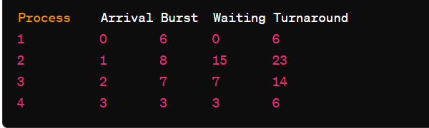

Lab Tasks

- For below processes, write FCFS and SJF processes to calculate waiting time for each process and average waiting time.

Process | Arrival Time | Execute Time
P0 | 0 | 5
P1 | 1 | 3
P2 | 2 | 8
P3 | 3 | 6

Solution: For FCFS

Process | Service Time - Arrival Time | Wait Time
P0 | 0-0 | 0
P1 | 5-1 | 4
P2 | 8-2 | 6
P3 | 16-3 | 13

Average Wait Time = (0+4+6+13)/4 = 5.75

For SJF

Process | Service Time - Arrival Time | Wait Time
P0 | 0-0 | 0
P1 | 5-1 | 4
P2 | 14-2 | 12
P3 | 8-3 | 5

Average Wait Time = (0+4+12+5)/4=5.25

- For below processes, write FCFS and SJF processes to calculate waiting time for each process and average waiting time.

Process | Arrival Time | Execute Time
P0 | 2 | 6
P1 | 5 | 2
P2 | 1 | 8
P3 | 0 | 3
P4 | 4 | 4

Solution: For FCFS

Process | Service Time - Arrival Time | Wait Time
P0 | 11-2 | 9
P1 | 21-5 | 16
P2 | 3-1 | 2
P3 | 0-0 | 0
P4 | 17-4 | 13

Average Wait Time = (9+16+2+0+13)/5 = 8

For SJF

Process | Service Time - Arrival Time | Wait Time
P0 | 0-0 | 0
P1 | 3-2 | 1
P2 | 9-5 | 4
P3 | 11-4 | 7
P4 | 15-1 | 14

Average Wait Time = (0+1+4+7+14)/5=5.2

